**DAILY ONLINE ACTIVITIES SUMMARY**

|  |  |  |  |  |  |  |  |
| --- | --- | --- | --- | --- | --- | --- | --- |
| **Date:** | **30/06/20** | | | | **Name:** | **Harshitha M** | |
| **Sem & Sec** | **8th sem, A sec** | | | | **USN:** | **4AL16CS038** | |
| **Online Test Summary** | | | | | | | |
| **Subject** | | **Not conducted** | | | | | |
| **Max. Marks** | |  | | **Score** | |  | |
| **Certification Course Summary** | | | | | | | |
| **Course** | **Introduction to R Language tutorial** | | | | | | |
| **Certificate Provider** | | | **Great Learning** | **Duration** | | | **9hrs** |
| **Coding Challenges** | | | | | | | |
| **Problem Statement: Write a C program to generate first n ugly numbers** | | | | | | | |
| **Status: Completed** | | | | | | | |
| **Uploaded the report in Github** | | | | **Yes** | | | |
| **If yes Repository name** | | | | **Harshitha-M** | | | |
| **Uploaded the report in slack** | | | | **Yes** | | | |

Online Test Details: Not conducted

Certification Course Details:

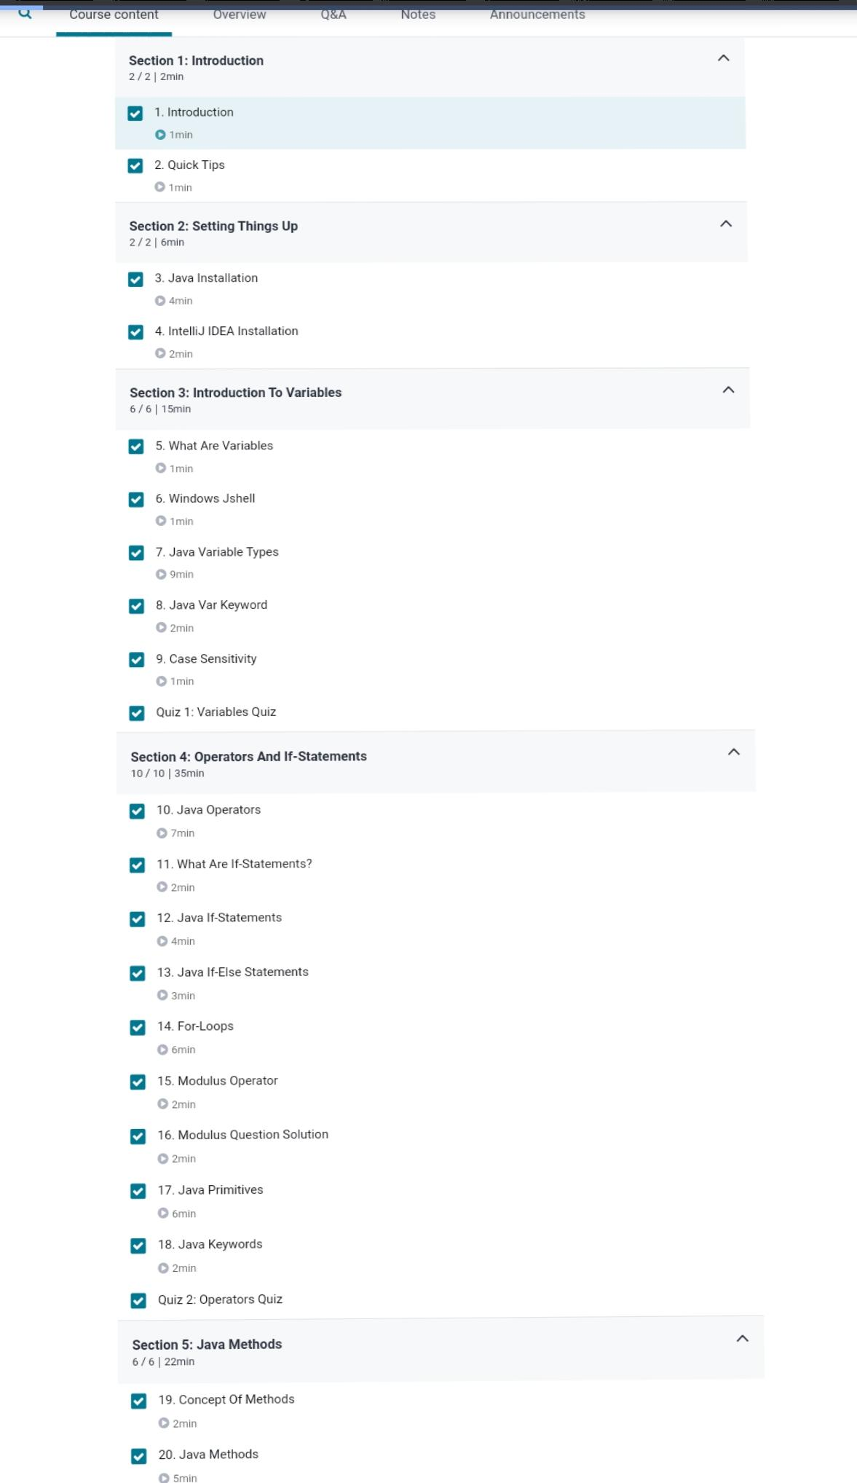

Coding Challenges Details:

|  |
| --- |
| #include<stdio.h> |
|  | #include<stdlib.h> |
|  |  |
|  | int maxDivide(int a, int b) |
|  | { |
|  | while (a%b == 0) |
|  | a = a/b; |
|  | return a; |
|  | } |
|  |  |
|  | int isUgly(int no) |
|  | { |
|  | no = maxDivide(no, 2); |
|  | no = maxDivide(no, 3); |
|  | no = maxDivide(no, 5); |
|  |  |
|  | return (no == 1)? 1 : 0; |
|  | } |
|  |  |
|  | int getNthUglyNo(int n) |
|  | { |
|  | int i = 1; |
|  | int count = 1; /* ugly number count */ |
|  |  |
|  | while (n > count) |
|  | { |
|  | i++; |
|  | if (isUgly(i)) |
|  | count++; |
|  | } |
|  | return i; |
|  | } |
|  |  |
|  |  |
|  | int main() |
|  | { |
|  | int n,i; |
|  | printf("Enter the number: "); |
|  | scanf("%d",&n); |
|  | for(i=1;i<=n;i++) |
|  | { |
|  | unsigned no = getNthUglyNo(i); |
|  | printf("%d ", no); |
|  | } |
|  | return 0; |
|  | } |